Ultimate Challenge

This is a report on the first part of the Ultimate Challenge data analysis interview; the exploratory data analysis part.

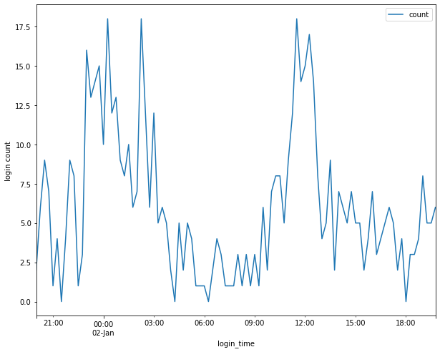

* Login peak hour is from 22:00 to 5:00
* Max peak hours is from 4:00 to 6:00AM with 50 to 73 logins

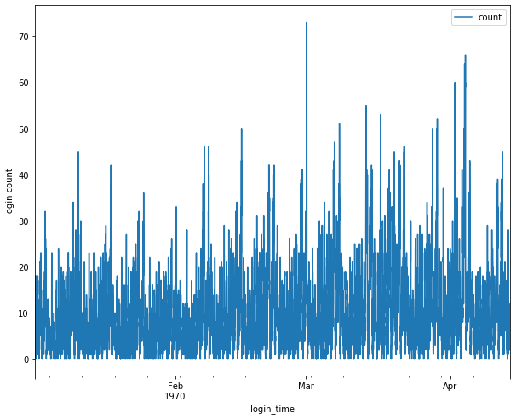

* Based on moving average window of past 100 logins, there is an increase on the login from 10 to 15 logins from January to April 1970
* Highest number of logins in March 1970